**Seminar #1 Report**

Nie Yongxin, 2186113564

# Topic

A brief introduction to the Mac adapter and a introductory report about the power electronic device——KBP408G. Besides, there are several simulation experiments concerning the parameters of BSC520N15NS3 to be presented.

# Simulation Model

## There are 5 characteristics to be specified and 1 model is established correspondingly. Besides, there is a kind of common power electronics equipment to be presented.

## ***2.1 Topic 1***

2.1.1 brief introduction

The specific meaning of switching power supply is to use modern electronic technology to control the switching time ratio and maintain stable output voltage. With the rapid development of modern electronic technology and the continuous upgrading and improvement of the corresponding architecture, switching power supply has also undergone great changes and development. At present, the switching power supply with the characteristics of small size, light weight, high stability and easy to carry is more popular. In addition, these characteristics of switching power supply make it widely used in many electronic devices.

Switching power supply is an essential form of power supply for the development of today's society. The future development of switching power supply must be high frequency, high reliability, good safety, low energy consumption, less pollution and strong anti-interference ability. At present, many foreign countries make use of the characteristics of switching power supply to continuously develop new high intelligent components. They have more professional technology on the loss of secondary rectifier components, and increase scientific and technological innovation in power ferrite materials to increase high frequency and large magnetic flux density to obtain higher magnetic properties.

The equipment we are going to introduce today is the 96W power adapter for the Macbook.



Figure 1 the adapter and the instruction

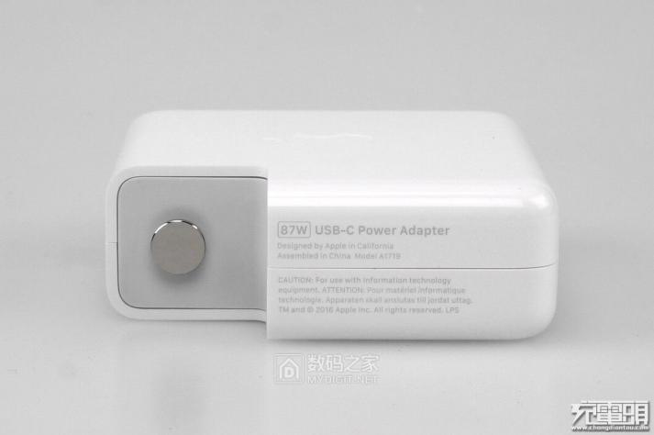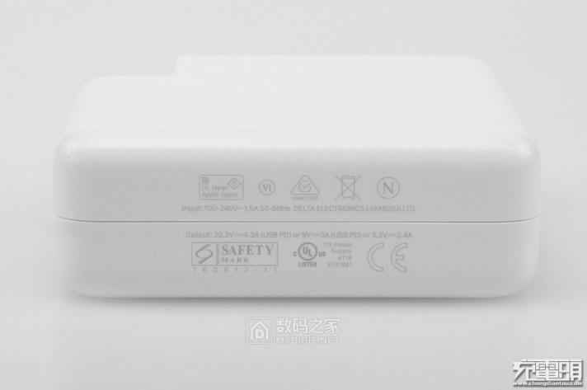

Figure 2 the front and back view of USB-C power adapter

2.1.2 function, input and output features

To begin with, the adapter is used to charge the Macbook, a kind of laptop produced by Apple Inc, whose power stage is 98 watts. This adapter support input voltage, from 100V to 240V, input current, 1.5A and the frequency, from 50Hz to 60Hz. Meanwhile, the adapter also supports 4 different kinds of output features including 20.5V+4.7A, 15V+3A, 9V+3A and 5.2V+3A, which could be used as the charger of any equipment supporting PD charging.

(1) *Basic principle diagram of switching power supply*

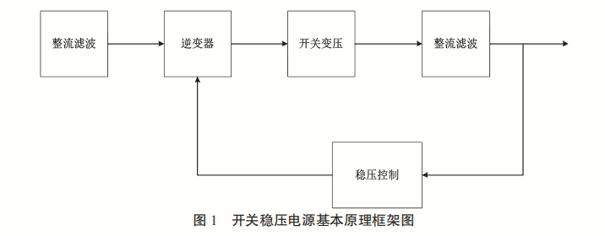

Figure 3 basic principle diagram of switching power supply

(2) *specific input and output features*

|  |  |
| --- | --- |
| Input voltage | 100-240V |
| Input current | 1.5A |
| Input frequency | 50-60Hz |
| Output voltage | 20.2/9/5.2V |
| Output current | 4.3/3/2.4A |

2.1.3 dismantling diagram

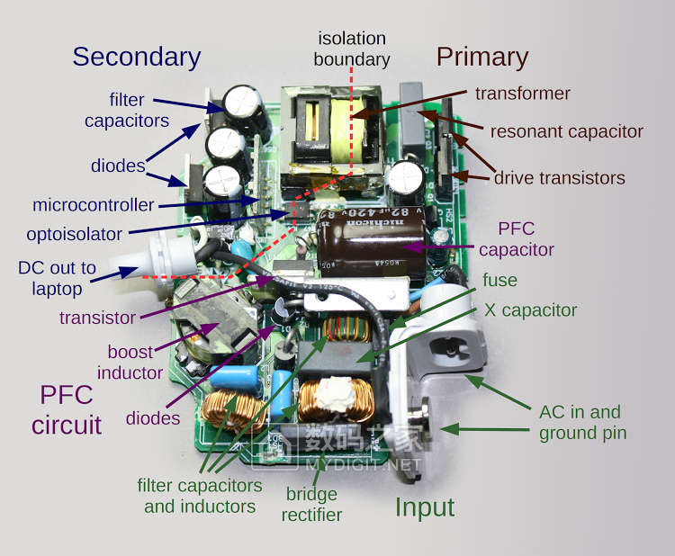

Figure 4 Front view of PCB

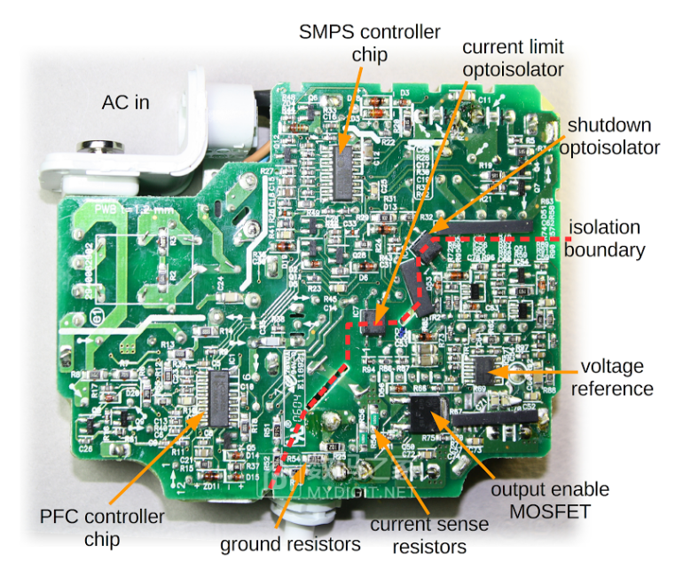

Figure 5 Back view of PCB

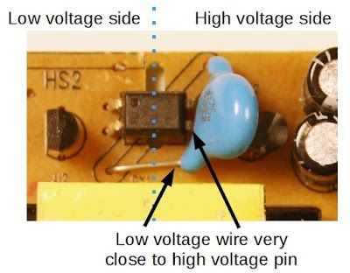

Figure 6 low voltage side and high voltage side

2.1.4 Circuit diagram and device function description

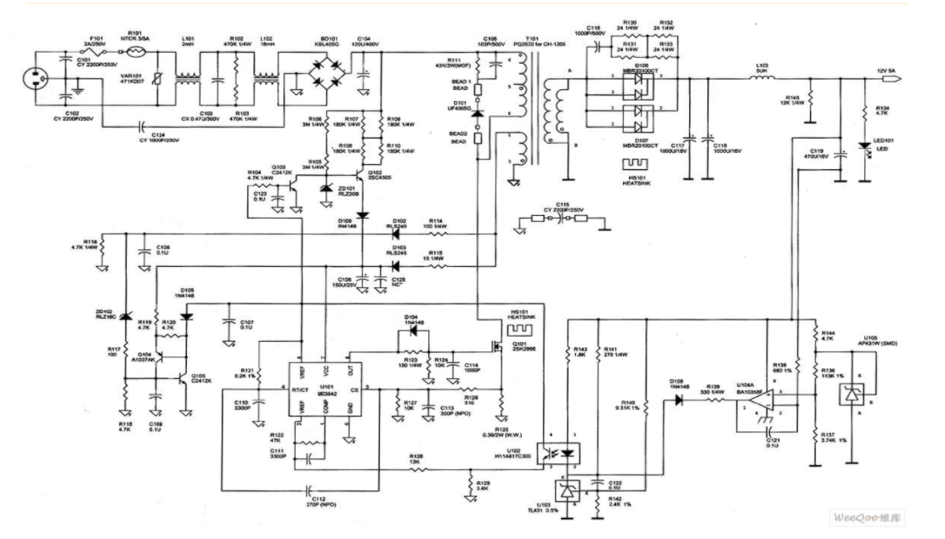

Figure 7 General circuit diagram

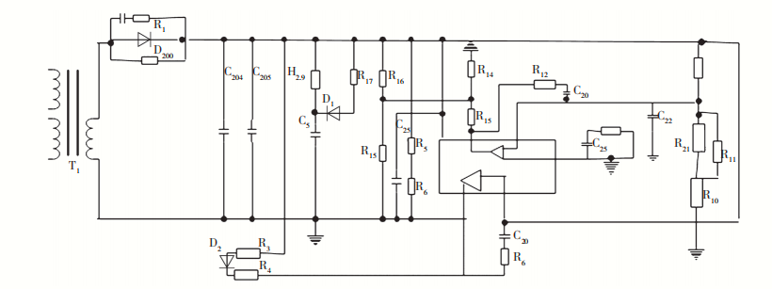

Figure 8 Control circuit schematic diagram

Introductory remarks:

(1) Varistor. When the voltage reaches a certain height, the value of varistor will be adjusted rapidly, and its value will become infinitely small. The fuse in series in the circuit will be quickly blown, and other components in the circuit will be well preserved.

(2) Inductance coil. Inductance coil is mainly used to reduce battery interference.

(3) Rectifier bridge. The main function of rectifier bridge is to convert 220 V alternating current into direct current.

(4) Filter capacitor. The main function of the filter capacitor is to filter out the AC wave in the direct current to ensure the safe and reliable operation of the circuit.

(5) Temperature probe. The temperature probe is used to detect the operating temperature of the power adapter. When the working temperature of the power adapter reaches a certain temperature, the temperature probe will automatically cut off the output current to ensure that other components in the adapter are in good condition.

(6) High power switch tube. High power switch tube is an important part of switching power supply in the project, and its function is to control the switch.

(7) Switching transformer. Switching transformer is one of the core components of switching power supply.

1. Secondary rectifier tube. The main function of secondary rectifier is to convert low voltage alternating current into low voltage direct current.

2.1.5 Component

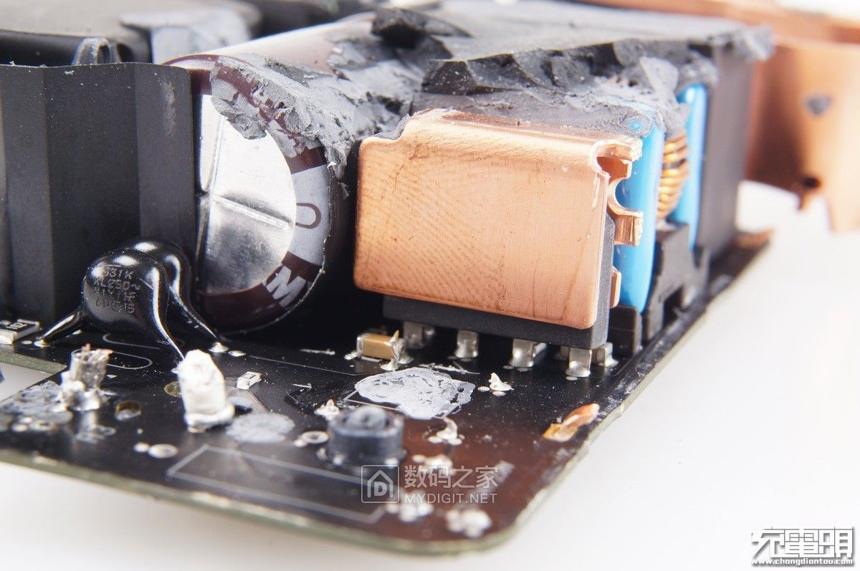

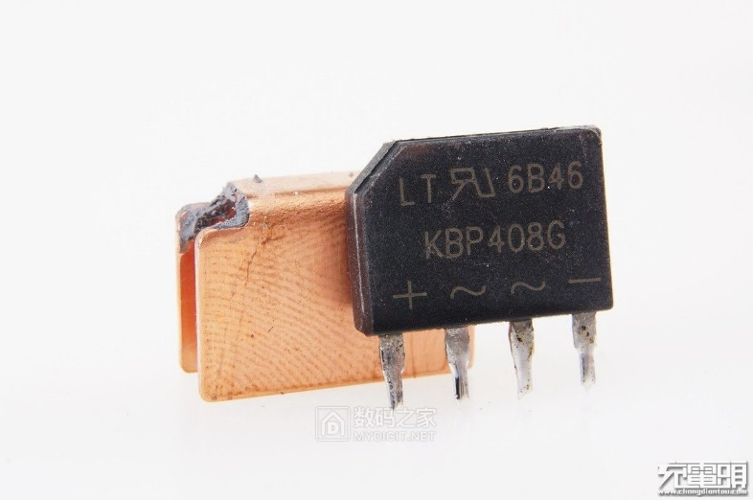

Figure 9 the KBP408G from the Mac adapter

Rectifier diode——KBP408G



Figure 10 the basic features and parameters concerning KBP408G

Rectifier diodes are generally planar silicon diodes, which are used in various power supply rectifier circuits.

When choosing rectifier diodes, the maximum rectifier current, maximum reverse working current, cut-off frequency and reverse recovery time should be considered. Rectifier diodes use the unidirectional conductivity of PN junction to change alternating current into pulsating direct current. The leakage current of rectifier diodes is large, and most of them are packaged with surface contact materials. The maximum rectifier current refers to the maximum current value allowed by the rectifier diode for a long time. It is the main parameter of the rectifier diode and the main basis for the selection of rectifier diode.

Rectifier diodes used in rectifier circuit and pulse rectifier circuit of switching regulated power supply should be those with higher working frequency and shorter reverse recovery time (such as RU series, EU series, V series, 1SR series, etc.) or fast recovery diodes.

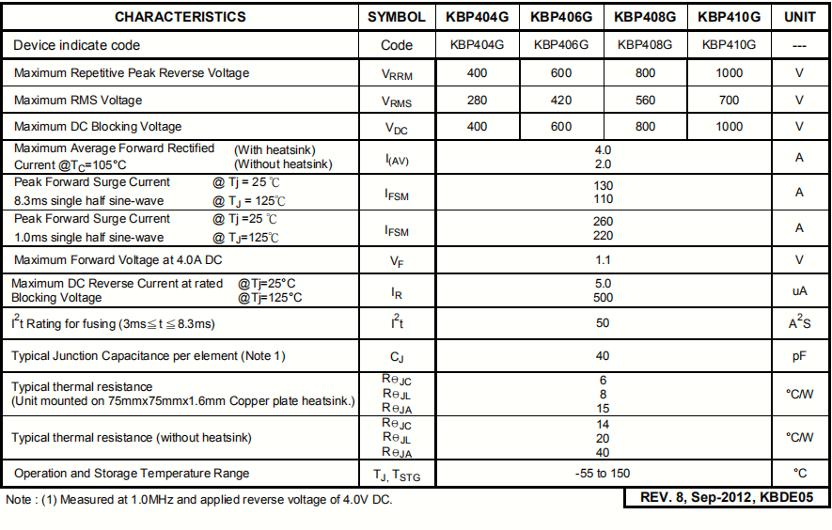

Table 1 the specific parameters of KBP408G

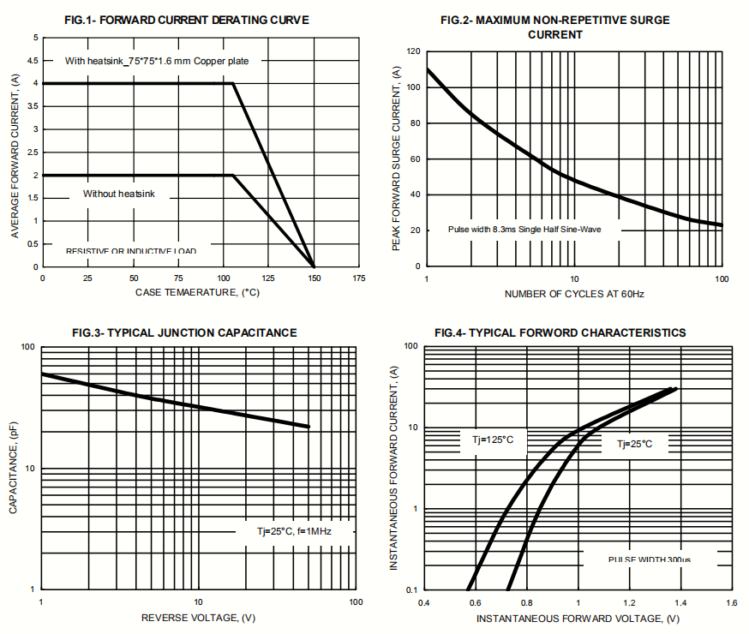



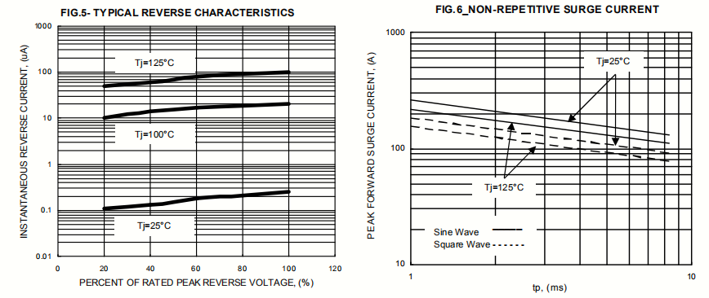

Figure 11 the characteristic curve of KBP408G

## ***2.2 Topic 2***

2.2.1 Simulation model 1

This model is established to find out the Output characteristics, Drain-source on resistance, Transfer characteristics and Switching waveform of MOSFET BSC520N15NS3 device. It includes a resistor, two voltage sources, a MOSFET BSC520N15NS3.

# 

Figure 12 the circuit of simulation model 1

When VGS and VDS get a series of different values, we can get a bunch of curves of ID, which is the Output characteristics. When VGS and VDS get a series of different values, we can get a bunch of curves of ID,and then divide VDS by ID to get RDS(on) , which is Drain-source on resistance. When VGS gets a series of different values, VDS is fixed and we simulate at different temperatures, we can get a bunch of curves of ID , which is Transfer characteristics. When we simulate Time-domain simulation, VGS being pulsating signal, we can get switching waveform correspondingly .

2.2.2 Simulation model 2

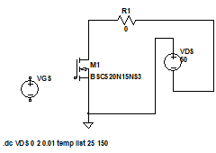

Figure 12 the circuit of simulation model 2

This model is established to find out the forward characteristics of reverse diode of MOSFET BSC520N15NS3 device. It includes a resistor, one voltage source, a MOSFET BSC520N15NS3. When VDS gets a series of different values at different temperatures, we can get different curves of IF.

# Parameter Setup

3.1 Output characteristics

VDS start value: 0 stop value: 3 increment: 0.1

VGS start value: 4 stop value: 10 increment: 0.5

R = 1

3.2 Drain-source on resistance

VDS start value: 0 stop value: 20 increment: 0.1

VGS start value: 5 stop value: 10 increment: 1

R = 1

3.3 Transfer characteristic

VGS start value: 0 stop value: 8 increment: 0.8

Tj start value: 25 stop value: 150 increment: 125

VDS = 150

R = 1

3.4 Forward characteristics of reverse diode

VSD start value: 0 stop value: 2 increment: 0.1

Tj start value: 25 stop value: 150 increment: 125

R = 1

3.5 Switching waveform

VGS

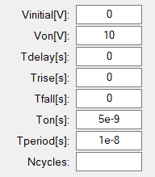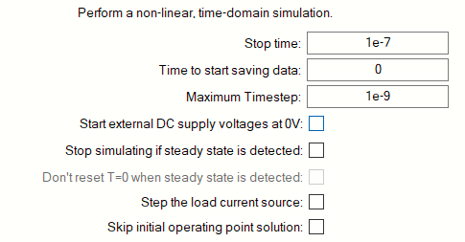VDC = 10, R = 1

# Simulation Results

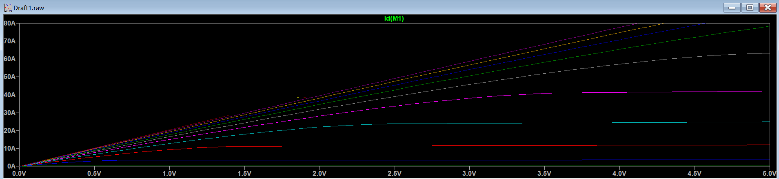

Figure 1 Output characteristics

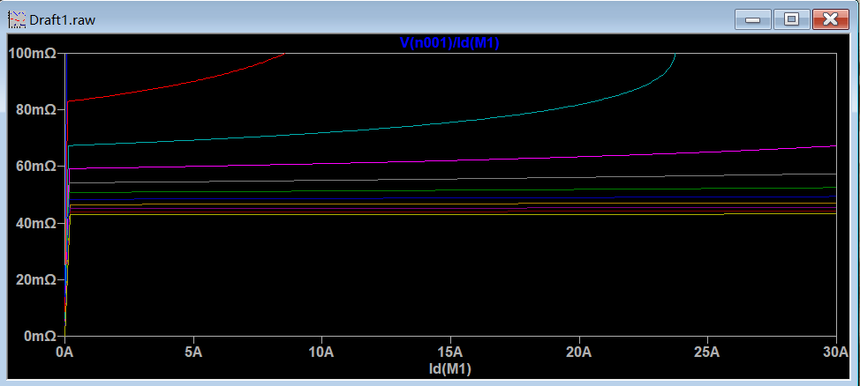

Figure 2 Drain-source on resistance

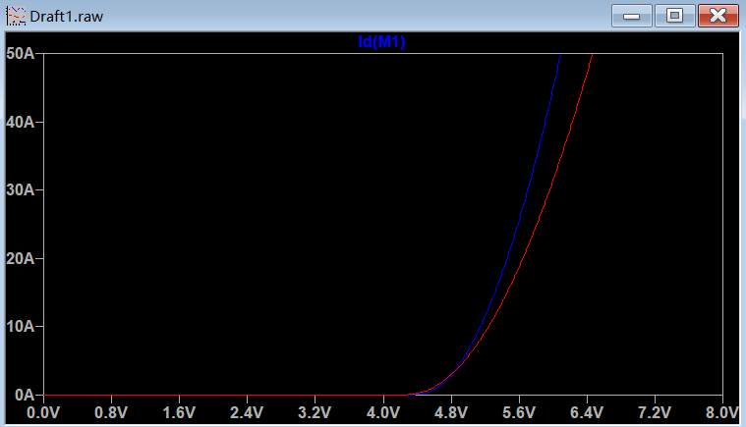

Figure 3 Transfer characteristics

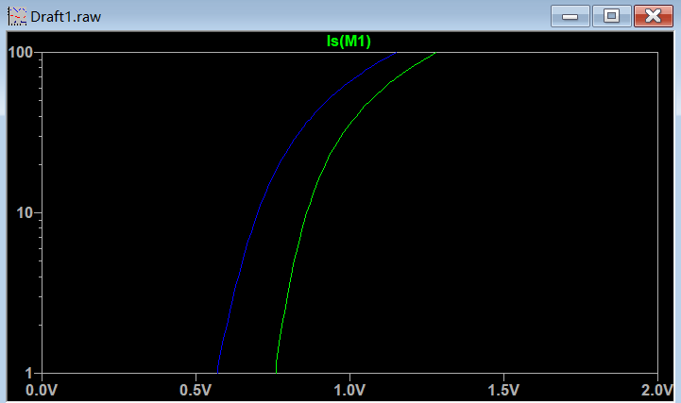

Figure 4 Forward characteristics of reverse diode



Figure 5 Switching waveform (real-time simulation, VGS being pulsating signal)

# Analysis of the Results

5.1 Output characteristic

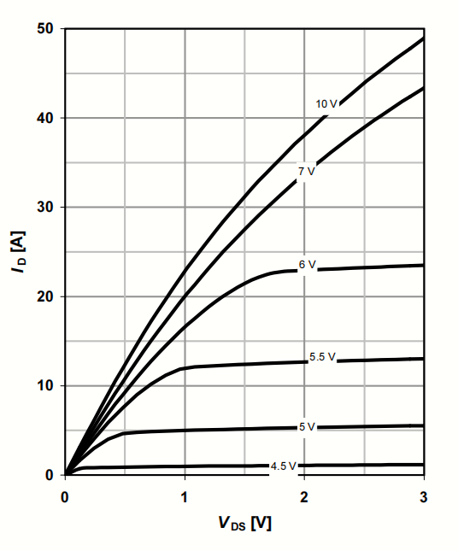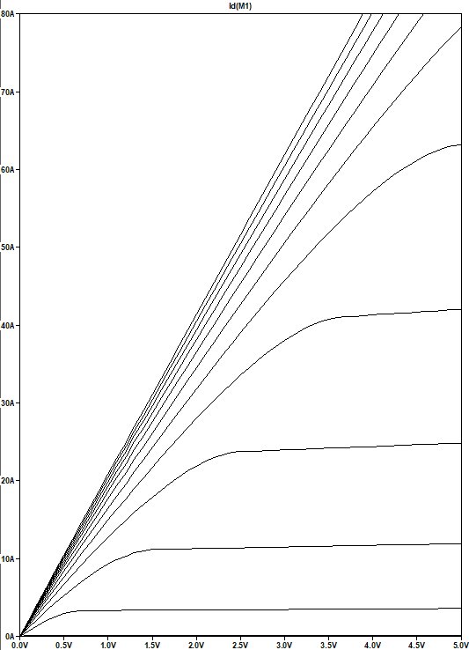

Figure 1 the simulation of output characteristics and the curve in the file

Compared with the output characteristics given by datasheet, the images are approximately identical.

When the VGS is bigger than 4.5V, the larger the VGS, the larger the ID, and tend to saturation with the increase of VDS.

5.2 Drain-source on resistance

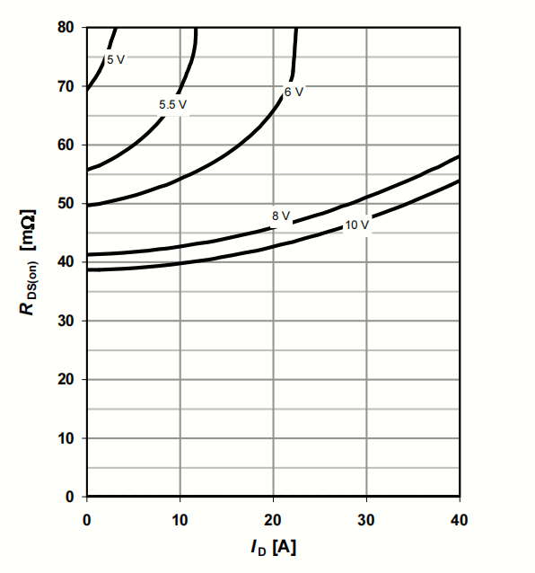 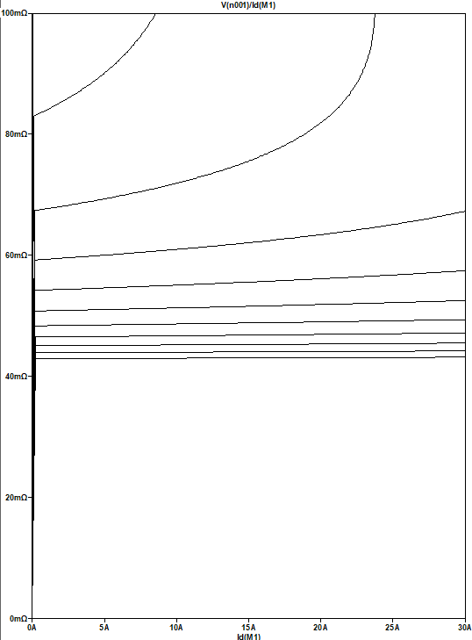

Figure 2 the simulation of drain-source on resistance and the curve in the file

Compared with drain-source on resistance given by datasheet, the images are approximately identical. RDS(on) decreases with the increase of VGS, and increases with the increase of ID.

5.3 Transfer characteristic

Compared with transfer characteristics given by datasheet, the images are approximately identical. The higher the temperature is, the smaller the voltage required for MOSFET conduction.

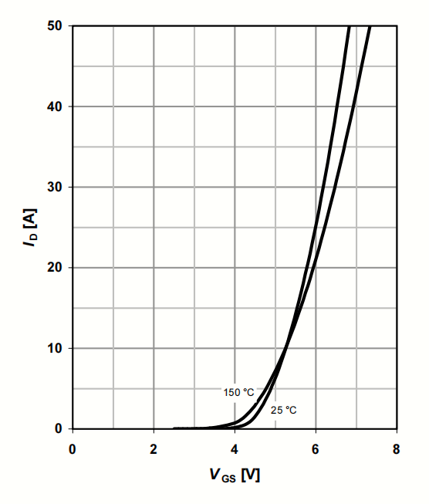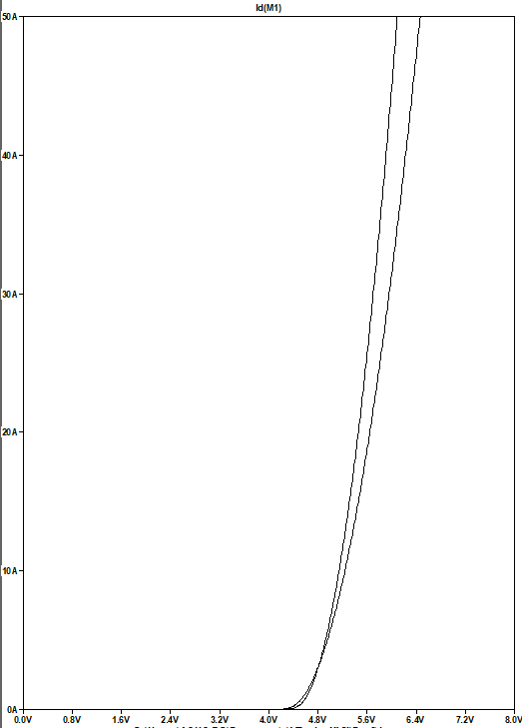

Figure 3 the simulation of transfer characteristic and the curve in the file

5.4 Forward characteristics of reverse diode

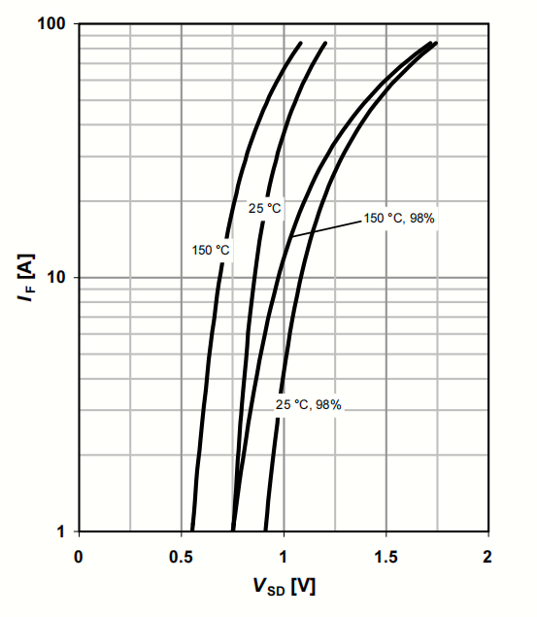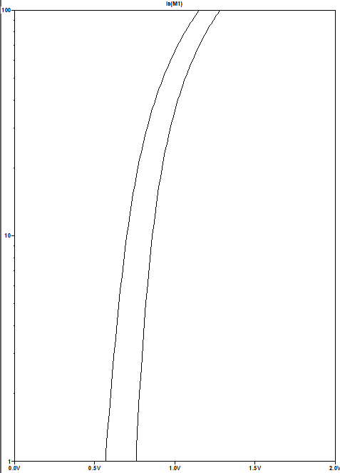

Figure 4 the simulation of forward characteristics of reverse diode and the curve in the file

Compared with transfer characteristics given by datasheet, the images are approximately identical.The IF of reverse diode increases with temperature and tends to saturation with the increase of VSD.

5.5 Switching waveform

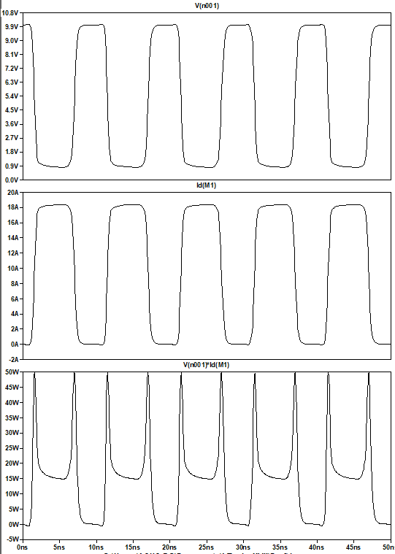

Figure 5 the simulation of Switching waveform

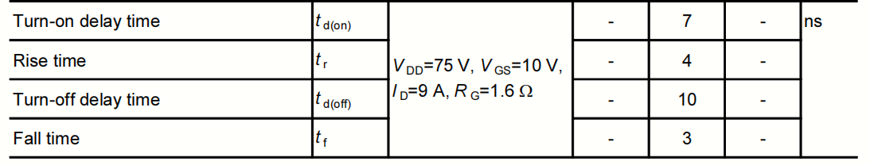

Table 1 the simulation result of switching waveform

The transmission delay of MOSFET BSC520N15NS3 is nanosecond. Since the period of VGS is also nanosecond, the waveform will show the charging and discharging process of interelectrode capacitance, so the waveform is not regular square wave.